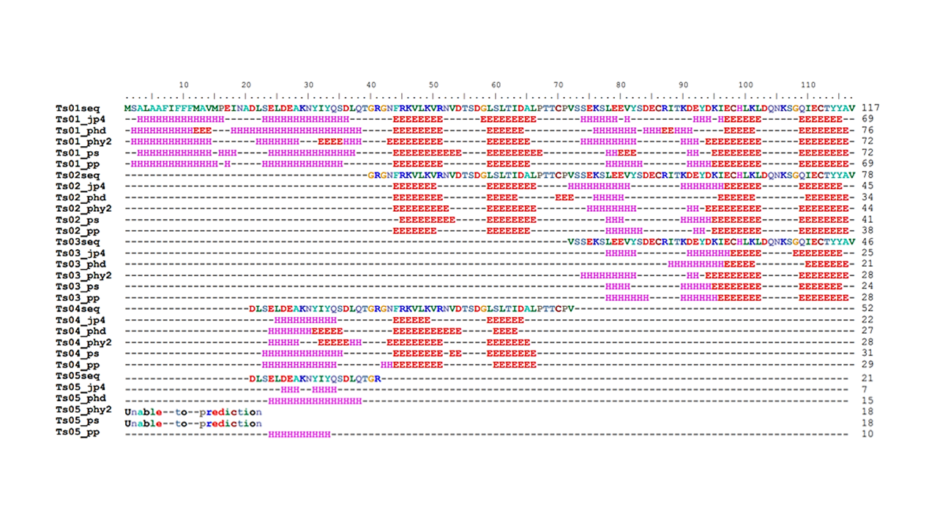
Supplementary Figure S3. The secondary (2D) structure of TsCstN (Ts01) and truncates Ts02, Ts03, Ts04, and Ts05 were performed by using five different software including Jpred4 (jp4), PHD (phd), Phyre2 (phy2), PSIPRED (ps), and PredictProtein (pp). Then each structure was aligned by using BioEdit software. H: α-Helix, E: β-sheet and -: others.

