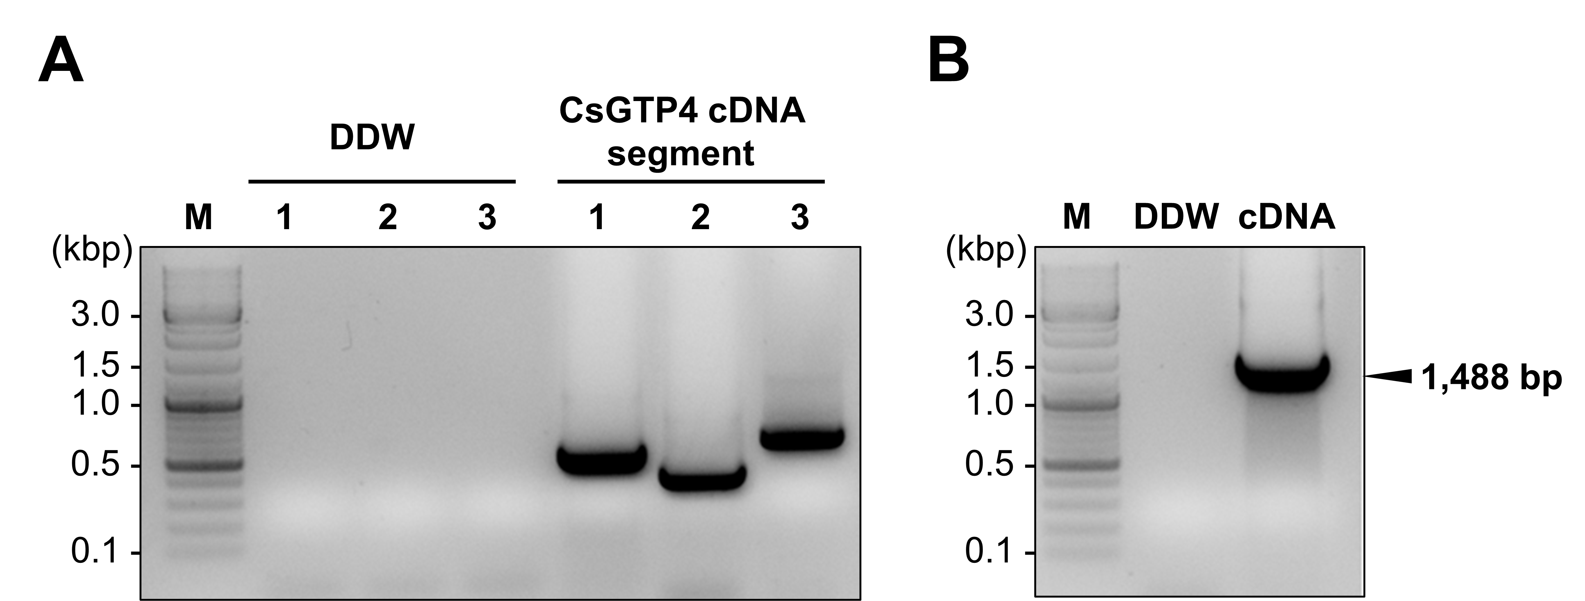
Supplementary Figure S1. Reverse transcription PCR for CsGTP4 segments and overlapping PCR for cDNA preparation. (A) The size of cDNA segments was expected 516 bp, 437 bp, and 601 bp that overlap with each segment for 15 bp. (B) The size of full-length of cDNA was expected 1,488 bp.

