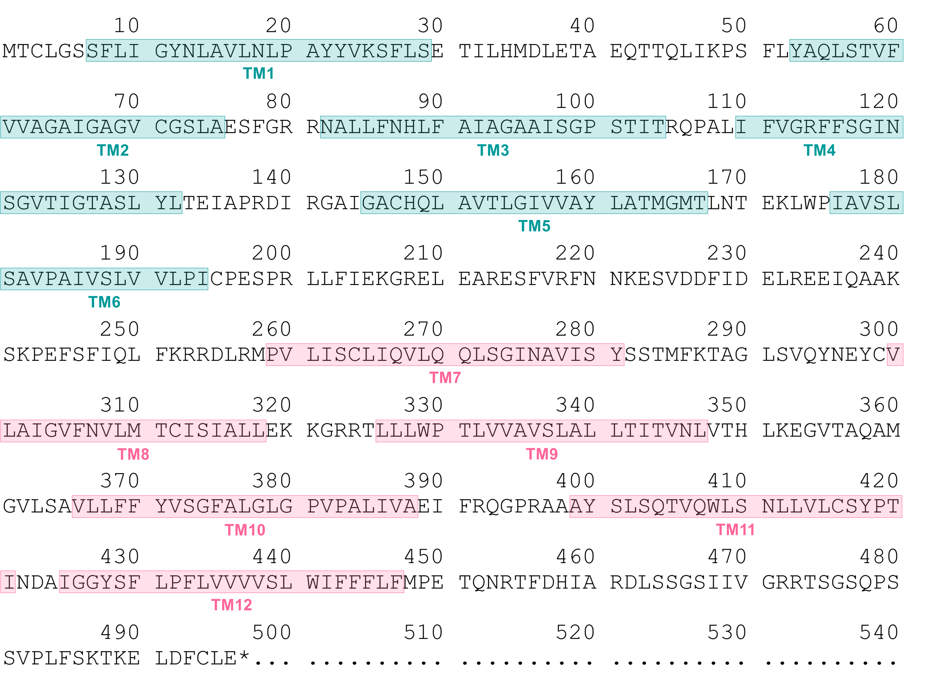
Supplementary Figure S3. The amino acid sequence of CsGTP4 and putative transmembrane segments.

