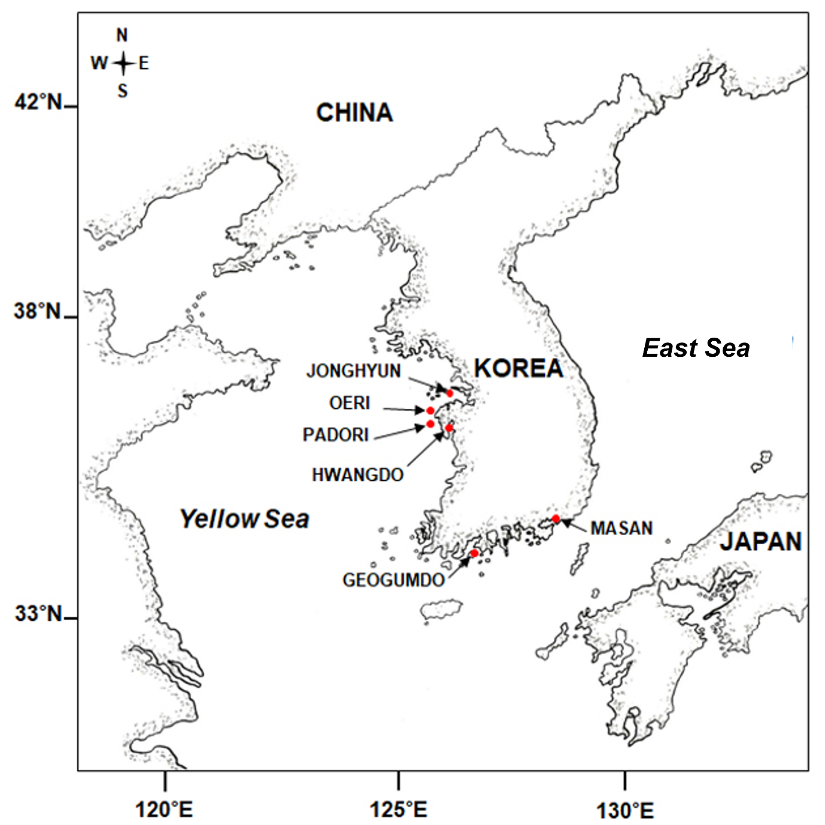

**Supplementary Fig. S1.** Map showing the 6 tidal flat sampling sites surveyed in this study.